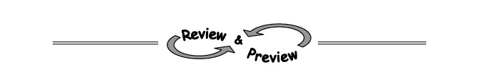
8-30. Remember that a square is a rectangle with four equal sides.
  - If a square has an area of 81 square units, how long is each side?

  - Find the length of the side of a square with area 225 square units.

  - Find the length of the side of a square with area 10 square units.

  - Find the area of a square with side 11 units.

8-31. Factor the following quadratic expressions, if possible.
  - k² − 12k + 20 b. 6x² + 17x – 14

c. x² − 8x + 16 d. 9m² – 1

b. Parts (a) through (c) are trinomials while part (d) is a binomial, yet they are all quadratics. What makes each of them a quadratic?

8-33. Solve each equation below for x. Check each solution.
  - 2x − 10 = 0 b. x + 6 = 0

c. (2x − 10)(x + 6) = 0 d. 4x + 1 = 0

e. x − 8 = 0 f. (4x + 1)(x − 8) = 0

