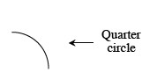
Unit 8 HW Day 2 8-31, 32, 37, 40, 42

8-31. The arc at right is called a quarter circle because it is one-fourth of a circle.
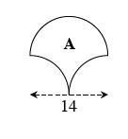
- Copy Region A at right onto your paper. If this region is formed using four quarter circles, can you find another shape that must have the same area as Region A? Justify your conclusion.
b. Find the area of Region A. Show all work.

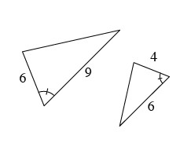
8-32. Multiple Choice: Which property below can be used to prove that the triangles at right are similar?
a. AA ∼
b. SAS ∼
c. SSS ∼
d. HL ∼
e. None of these

Interior and Exterior Angles of a Polygon
The properties of interior and exterior angles in polygons, where n represents the number of sides in the polygon (n-gon), can be summarized as follows:
- The sum of the measures of the interior angles of an n-gon is 180(n − 2).
- The measure of each angle in a regular n-gon is 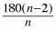.
- The sum of the exterior angles of an n-gon is always 360°.

8-37. Esteban used a hinged mirror to create an equilateral triangle, as shown in the diagram at right. If the area of the shaded region is 11.42 square inches, what is the area of the entire equilateral triangle? Justify your solution.
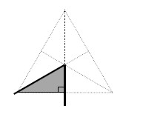
8-40. Find the number of sides in a regular polygon if each interior angle has the following measures.
a. 60° | b. 156° | c. 90° | d. 140°

8-42. Multiple Choice: A penny, nickel, and dime are all flipped once. What is the probability that at least one coin comes up heads?
a. | b. | c. 1 | d.

