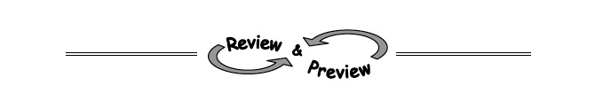
8-41. As Jhalil and Joman practice for the SAT, their scores on practice tests rise. Jhalil’s current score is 850, and it is rising by 10 points per week. On the other hand, Joman’s current score is 570 and is growing by 50 points per week.
  - When will Joman's score catch up to Jhalil's?

  - If the SAT test is in 12 weeks, who will score highest?

8-42. Mary says that you can find an x-intercept by substituting 0 for x, while Michelle says that you need to substitute 0 for y.
- Who, if anyone, is correct and why?

- Use the correct approach to find the x-intercept of −4x + 5y = 16.

8-43. Find three consecutive numbers whose sum is 138 by writing and solving an equation.

8-44. Match each rule below with its corresponding graph. Can you do this without making any tables? Explain your selections.
a. y = −x² − 2 | b. y = x² − 2 | c. y = −x² + 2

