Unit 8 HW Day 3 8-49, 50, 55, 56, 60

Parts of a Regular Polygon

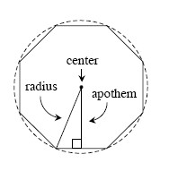
The center of a regular polygon is the center of the smallest circle that completely encloses the
polygon.
A line segment that connects the center of a regular polygon with a vertex is called a radius.
An apothem is the perpendicular line segment from the center of a regular polygon to a side.
8-49. The exterior angle of a regular polygon is 20°. Hints⇔Help
  - What is the measure of an interior angle of this polygon? Show how you know.
  - How many sides does this polygon have? Show all work.

8-50. Find the exact values of x and y in each diagram below.
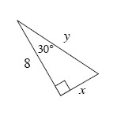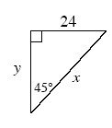

8-55. Solve for x in each diagram below. Hints⇔Help
- 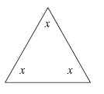 b.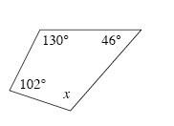

c.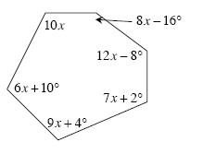 d. 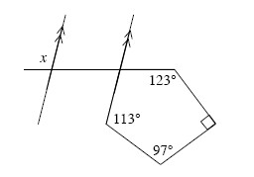

8-56. What is another (more descriptive) name for each polygon described below? Hints⇔Help
- A regular polygon with an exterior angle measuring 120°.
- A quadrilateral with four equal angles.
- A polygon with an interior angle sum of 1260°.
- A quadrilateral with perpendicular diagonals.

8-60. Multiple Choice: Approximate the length of . Hints⇔Help
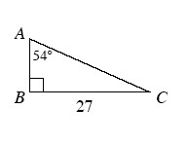
a. 15.87 | b. 21.84 | c. 37.16 | d. 19.62 | None of these

