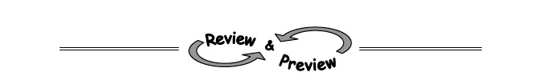
8-49. Factor each polynomial.
  - x² – 64 b. y² − 6y + 9

c. 4x² + 4x + 1 d. 5x² − 45

8-50. The negative exponent rule is shown by the pattern, a^{-m} = 1/a^{m} . This means that you turn the base upside down make the exponent positive:
Example: ${\left(\frac{4}{5}\right)}^{-2}= {\left(\frac{5}{4}\right)}^{2}= \left(\frac{5}{4}\right)\left(\frac{5}{4}\right)= \left(\frac{25}{16}\right)$.
a. 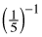 b. 100⁻¹ c. 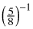

d. 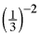 e. 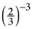 f. 6⁻³
g. 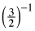 h. 2⁻⁵ i. 3⁻²

8-51. Solve each of the following systems of equations algebraically. Then confirm your solutions by graphing.
  - y = 4x + 5 b. 2x + y = 9
y = −2x – 13 y = −x + 4

8-53. Solve the following equations for x.
  - 4x − 6y = 20 b. (x − 6) = 9

