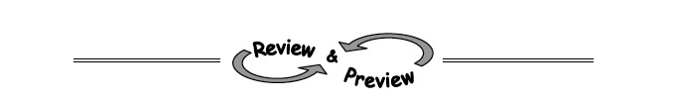
8-58. Graph y = x² − 8x + 7 and label its vertex, x-intercepts, and y-intercepts.
8-60. Based on the tables below, say as much as you can about the x- and y-intercepts of the corresponding graphs.
a.
x | 2 | 0 | -4 | -1 | 6 | 3
y | 0 | 18 | 0 | -8 | 22 | 0

b.
x | 7 | 3 | 10 | 0 | 8 | -7
y | -4 | 0 | 8 | -3 | 0 | -1

c.
x | 0 | -5 | 3 | 1 | 13 | -6
y | -4 | 11 | -2 | 0 | 27 | 14

8-62. Solve the following systems of equations using any method. Check your solution if possible.

- 6x − 2y = 10 b. x − 3y = 1
y = 16 − 2x 3x − y = 2

8-61. In speed golfing an athlete’s score is determined by adding the number of strokes to complete a course to the minutes required to finish. For example 90 strokes in 51 minutes would be a score of 141. The lower the score, the better. Diego wants to see if there is a relationship between the time, t, it takes for him to complete a speed golfing match and the number of strokes, s, he takes in the same match. If so, perhaps focusing on running faster will also reduce the number of strokes.
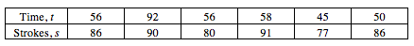
  - Create a scatterplot with pencil and paper. Determine Diego’s best score and circle the point representing Diego’s best total score.

  - Write what you can about the association from observation of the scatterplot.

  - Diego recalls that he was suffering from seasonal allergies that slowed his running on a particular course. Cross-out that point. Then use your intuition and draw a line of best fit from the remaining points.

  - Estimate the slope of your trend line and interpret it in the context of the problem.

  - Should Diego train to reduce his time so that he sees an increase in his golf score?

