The Area of a Regular Polygon 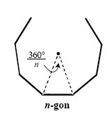
If a polygon is regular with n sides, it can be subdivided into n congruent isosceles triangles. One way to calculate the area of a regular polygon is to multiply the area of one isosceles triangle by n.
To find the area of the isosceles triangle, it is helpful to first find the measure of the polygon’s central angle by dividing 360° by n. The height of the isosceles triangle divides the top vertex angle in half.
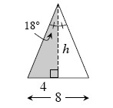
For example, suppose you want to find the area of a regular decagon with side length 4 units. The central angle is = 36°. Then the top angle of the shaded right triangle at right would be 36° ÷ 2 = 18° .
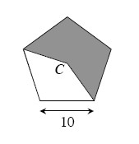
Use right triangle trigonometry to find the measurements of the right triangle, then calculate its area. For the shaded triangle above, tan 18° = and h ≈12.311. Use the height and the base to find the area of the isosceles triangle: (8)(12.311) ≈ 49.242 sq. units. Then the area of the regular decagon is approximately 10 · 49.242 ≈ 492.42 sq. units. Use a similar approach if you are given a different length of the triangle.

8-85. Find the area of the shaded region for the regular pentagon at right if the length of each side of the pentagon is 10 units. Assume that point C is the center of the pentagon.

8-87. Find the measure of each interior angle of a regular 30-gon using two different methods.

- 8-89. On graph paper, plot the points A(−3, −1) and B(6, 11).
  - Find the midpoint of .
  - Find the equation of the line that passes through points A and B.
  - Find the distance between points A and B.
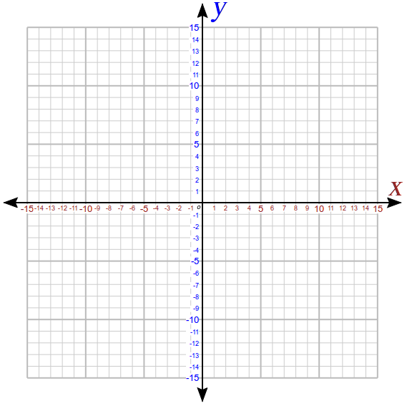

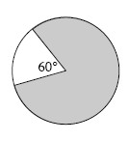
- 8-90. Multiple Choice: What fraction of the circle at right is shaded? Hints⇔Help
  - A.
B.
C.

