Unit 9 Day 7 Homework 9-99, 9-103, 11-101, 11-114

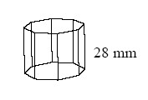
CL 9-99. Find the volume and surface area of the prism at right if the base is a regular octagon with side length 14 mm and the height of the prism is 28 mm.

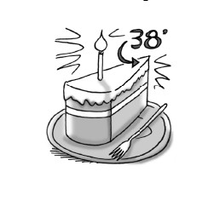
CL 9-103. After Myong's cylindrical birthday cake was sliced, she received the slice at right. If her birthday cake originally had a diameter of 14 inches and a height of 6 inches, find the volume of her slice of cake.

11-101. Multiple Choice: Which of the following cannot be the measure of an exterior angle of a regular polygon?
- 18°
- 24°
- 28°
- 40°

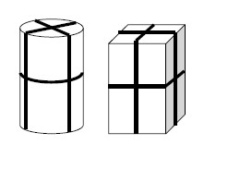
CL 11-114. Talila is planning on giving her geometry teacher a gift. She has two containers to choose from:
  - A cylinder tube with diameter 6 inches and height 10 inches

  - A rectangular box with dimensions 5 inches by 6 inches by 9 inches

  - Assuming that her gift can fit in either box, which will require the least amount of wrapping paper?

  - She plans to tie two loops of ribbon about the package as shown at right. Which package will require the least amount of ribbon? Ignore any ties or bows.

