A-53. Simplify the following expressions by combining like terms, if possible.
  - x + x − 3 + 4x² + 2x − x
  - 8x² + 3x − 13x² + 10x² − 25x − x
  - 4x + 3y
  - 20 + 3xy − 3 + 4y² + 10 − 2y²

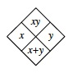
A-54. Complete each of the Diamond Problems below. The pattern used in the Diamond Problems is shown at right.
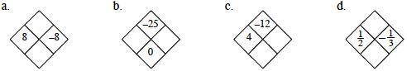

A-55. The two lines at right represent the growing profits of Companies A and B.
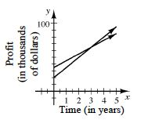

If Company A started out with more profit than Company B, determine which line represents A and which represents B. Label the lines appropriately.
- In how many years will both companies have the same profit?
- Approximately what will that profit be?
- Which company's profits are growing more quickly? How can you tell?
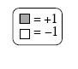
A-61. Find a simplified algebraic expression for each expression mat below.
- 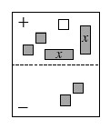
- 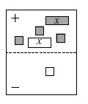
- 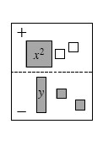
A-63. Without a calculator, compute the value of each expression below.
- 7 − 2 · (−5)
- 6 + 3(7 − 3 · 2)²
- 5 · (−3)²
- 35 ÷ (16 − 3²) · 2
- −3 · 4 + 5 · (−2)
- 7 − 6(10 − 4 · 2) ÷ 4

