A-71. Solve this problem by writing an equation. Write your answer in a complete sentence.
The number of students attending the Fall play was 150 more than the number of adults attending. A total of 1220 people attended the play. How many students attended the play?

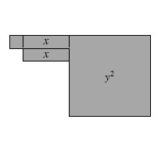
A-72. Sylvia simplified the expressions on the expression comparison mat shown below. Some of her work is shown. Are all of her moves “legal”? Explain.
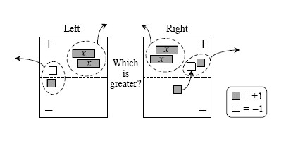

A-74. Examine the shape made with algebra tiles at right.

  - Write an expression that represents the perimeter of the shape. Then evaluate your expression for x = 6 and y = 10 units.

  - Write an expression that represents the area of the shape. What is the area if x = 6 and y = 10 units?
A-75. CALCULATOR CHECK
Use your scientific calculator to compute the value of each expression in the left-hand column below. Match each result to an answer in the right-hand column.
a. −3 + 16−(−5) | 1. −16
b. (3 − 5)(6 + 2) | 2. 327
c. 17(−23) + 2 | 3. 0.5
d. 5 − (3 − 17)(−2 + 25) | 4. 18
e. (−4)(−2.25)(−10) | 5. −90
f. −1.5−2.25−(−4.5) | 6. 0.75
g. | 7. −389

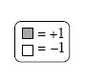
A-77. WHICH IS GREATER?
For each expression comparison mat below, simplify and determine which side is greater.
- 
 