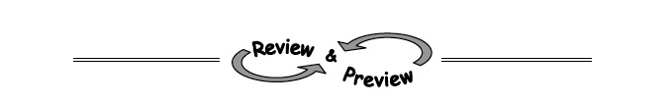
A-82. WHICH IS GREATER?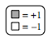
For each Expression Comparison Mat below, simplify and determine which side is greater.
  - 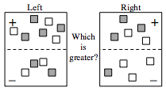

  - 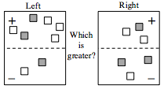

A-83. Solve this problem by writing an equation using only one variable. Then write your answer with a complete sentence.
Mairé is thinking of two numbers. The first number is 14 less than the second number. When she adds them, she gets 40. Help her younger sister, Enya, figure out the numbers.

A-84. Simplify each expression below as much as possible.
- 3y − y + 5x + 3 − 7x

- −1 − (−5x) − 2x + 2x² + 7

- 6x + 2 − 1 − 4x − 3 − 2x + 2

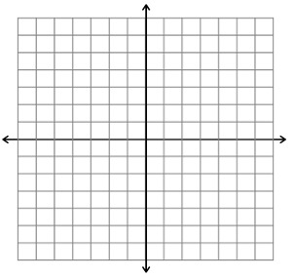
A-85. Plot the points (0, 0), (3, 2), and (6, 4) on graph paper. Then draw a line through the points. Name the coordinates of three more points on the same line.

A-86. Mr. Dexter’s teams earned the following scores on a quiz: 15, 20, 19, 20, 16, 20, 14, 18, and 17.
What is the mean (average score)?
What is the median (middle score)?

A-87. Simplify each expression.

