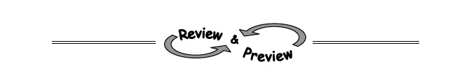
A-8. Find the find the area and perimeter of each shape. Assume that all corners are right angles. Show all work.
a. 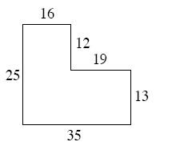
b. 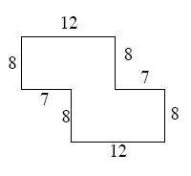

A-9. Find the perimeter of the entire rectangle shown below (that is, the outside boundary of the figure). Notice that the areas of two of the parts have been labeled inside the rectangle. Also find the total area. Remember to show all work leading to your solution.
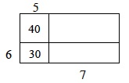

A-10. One meaning of the word evaluate is to find the value of an expression. To evaluate, replace a variable with a number and calculate the result. For example, when you are asked to evaluate the expression 4x − 2 when x = −7, you would put −7 in place of the variable and calculate: 4 (−7) − 2 = −30. Evaluate the expressions below for the given values of x and y.
  - + 9 if x = 3 b. 8x − 3 + y if x = 2 and y = 1

c. 2xy if x = 5 and y = −3 d. 2x² − y if x = 3 and y = 8

1-19. Solve each linear equation. Check your solutions.
  - −2x − 3 = 3 b. 7 + 2x = 4x – 3 c. 6x − 10 = −8 + 3x

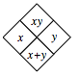
1-21. Complete each of the Diamond Problems below. The pattern used in the Diamond Problems is shown at right. Homework Help
