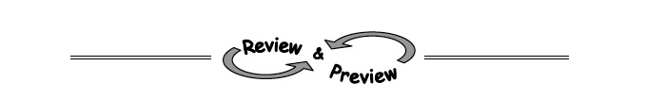
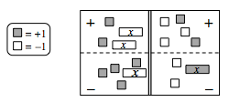
A-92. Translate the Equation Mat at right into an equation. Remember that the double line represents “equals.”

A-93. Ling wants to save $87 for tickets to a rock concert. If she has $23 now and will save $4 per week, how long will it take her to get enough money to buy the tickets?

A-94. On graph paper, plot the points (0, 0), (−2, 1), and (2, −1). Then draw a line through them. Name the coordinates of three more points on the same line.
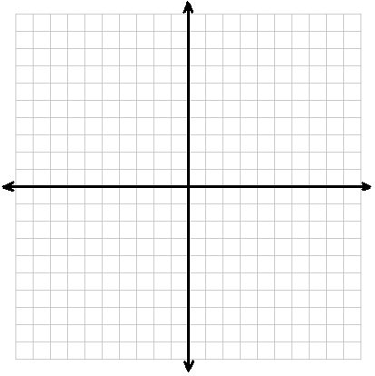

A-95. Solve each equation and then show the check to prove that your answer is correct.
- 2 − 4x = 8 – x b. x + 4 − 3x = 4 − (x − 1)

A-96. Use legal simplification moves to determine which side of the Expression Comparison Mat is greater.
a. 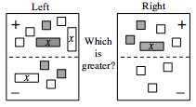 b. 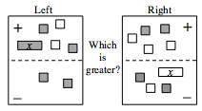

A-97. Evaluate the expressions below for the given values.
  - 6m + 2n² for m = 7 and n = 3

  - for x = −18

  - for x = 10

  - (k − 3)(k + 2) for k = 1

