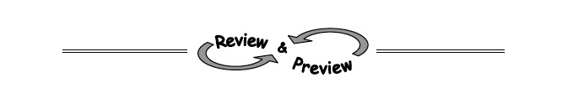
A-30. Copy and simplify the following expressions by combining like terms. Using or drawing sketches of algebra tiles may be helpful.
  - 2x + 3x + 3 + 4x² + 10 + x b. 4x + 4y² + y² + 9 + 10 + x + 3x

  - 2x² + 30 + 3x² + 4x² + 14 + x c. 20 + 5xy + 4y² + 10 + y² + xy

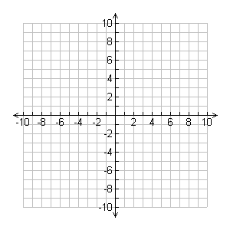
A-31. Plot the points A(5, 3), B(−4, 3), C(−4, −6), and D(5, −6) on a set of axes. Use a ruler to connect them in order, including D back to A, to form a quadrilateral (a shape with four sides).
- What kind of quadrilateral was formed?

- How long is each side of the quadrilateral?

- What is the area of the quadrilateral?

- What is the perimeter of the quadrilateral?

A-32. Write an equation to solve the following problem. Write your answer with a complete sentence.
Susan is buying three different colors of tiles for her kitchen floor. She is buying 107 red tiles, and three times as many navy-blue tiles as beige tiles. If Susan buys 435 tiles altogether, how many tiles of each color does she buy?
Let b = the number of beige tiles. Your equation should start with “435 =” and use b as the only variable.

A-44. Read the Math Notes box for this lesson. Then evaluate each equation below.
- For y = 2 + 3x when x = 4, what does y equal?

- For a = 4 – 5c when , what does a equal?

- For n = 3d ² – 1 when d = –5 , what does n equal?

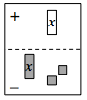
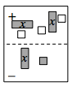
A-45. Write and simplify the algebraic expression shown in each expression mat below.
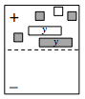
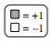

a. b. c.

