Catching Up with Exponential Functions

1. Sketch the following graphs
Linear Increase Linear Decrease Exponential Growth Exponential Decay
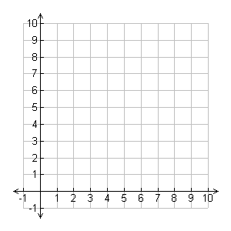
Describe some similarities and differences between these graphs.

2. Label the following forms with their y-intercept and rate of change.

$$y=mx+b$$

$$y=ab^{x}$$

y-intercept rate of change

3. Consider the following situations.
a. The NCAA men’s and women’s basketball tournaments begin with 64 teams. Half of teams win and advance to the next round. This pattern continues until there is a champion. Complete the table to show how many rounds there are in this tournament and then write an equation for this situation.

x | 0 | 1 | 2 | 3 | 4 | 5 | 6 | 7 | 8
y | 64

b. Dude is a bit of a hypochondriac and is concerned with how quickly a disease could spread through his town. Dude thinks; if a family of 5 returns from a trip abroad with a certain virus and each person infects 2 more people per day. And then each of the infected people infect 2 more per day. Complete a table that shows how quickly this disease could spread. Then write an equation for this situation.

x | 0 | 1 | 2 | 3 | 4 | 5 | 6 | 7 | 8
y | 5

c. Tomas' grandfather put $1000 in the bank for him when he was born. The account has been earning 5.25% interest compounded annually. Tomas is now 18 years old and wants to take out the money so he can go to college. How much money does he have now? Show how you got your answer.

d. I bought a brand-new truck for $35,000. It’s value is decaying at a rate of 18% every. How much is it worth in 10 years? Show how you got your answer.

4. Complete the following tables and show an equation for each.
x | y
0 | 3.25
1 | 3.9
2
3
4
5
6 | 9.7044
x | y
0 | 4
1 | 16
2
3 | 256
4
5
6
x | y
0 | 1000
1 | 750
2
3
4
5 | 237.3
6

5. Complete the Venn Diagram to compare Linear and Exponential Functions

