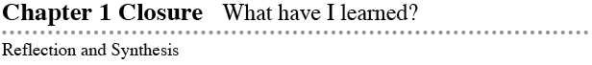
- CL 1-126. For the figures below, perform the indicated transformations and label each image with prime notation (A → A′).
a. Rotate EFGHI 90° clockwise about point Z b. Reflect JKLMN over line t
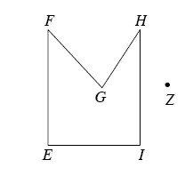
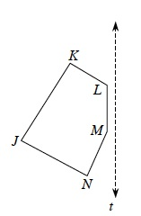

c. Using the grid provided, copy and translate ABCD down 5 units and right 3 units
y
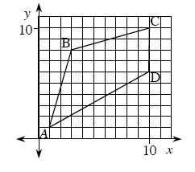

x

- CL 1-127. Assume that all angles in the diagram below are right angles and that all the measurements are in centimeters. Find the perimeter of the figure.
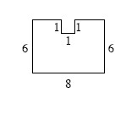

- CL 1-128. Estimate the measures of the angles below. Are there any that you know for sure?
  - a. b. c. d.
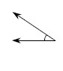
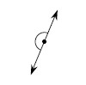
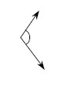
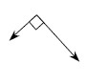

- CL 1-129. Examine the angles in problem CL 1-128. If these four angles are placed in a bag, what is the probability of randomly selecting:
a. An acute angle
b. An angle greater than 60°
c. A 90° angle
d. An angle less than or equal to 180°

- CL 1-130. Examine the shapes below.
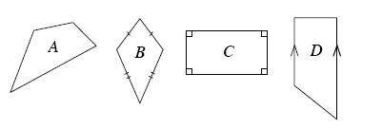
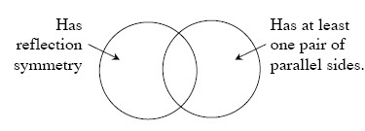
a. Name each shape based on its attributes.
b. Decide where each shape would be placed in the Venn diagram above.
c. Are any of the shapes regular? Explain your answer.

- CL 1-131. Solve each equation below. Check your solution.
a. 3x − 12 + 10 = 8 − 2x b.

c. 5 − (x + 7) + 4x = 7(x − 1) d. x² + 11 = 36

- CL 1-132. Graph and connect the points in the table below. Then find the equation for the data in the table. State the slope and y-intercept.
x | −4 | −3 | −2 | −1 | 0 | 1 | 2 | 3 | 4 | 5 | 6
y | −5 | −3 | −1 | 1 | 3 | 5 | 7 | 9 | 11 | 13 | 15

- CL 1-133. ΔABC below is equilateral. Use what you know about an equilateral triangle to write and solve an equation for x. Then find the perimeter of ΔABC.
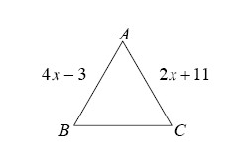

- 1-121. Examine the shapes listed on your Shapes Toolkit. Name a shape that meets the following conditions: It has a pair of congruent sides, it has one right angle, and it has three vertices.

- 1-124. Rosalinda examined the angles below and wrote the equation (2x + 1°) + (x − 10°) = 90°.
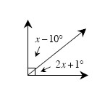
  - Does her equation make sense? If so, explain why her equation must be true. If it is not correct, determine what is incorrect and write the equation.
  - If you have not already done so, solve her equation, clearly showing all your steps. What are the measures of the two angles?
  - Verify that your answer is correct.

- 1-125. Copy the table below on your paper and complete it for the rule y = x² + 2x − 3. Then graph and connect the points on graph paper. Name the x-intercepts.
x | −4 | −3 | −2 | −1 | 0 | 1 | 2
y

