CLOSURE QUESTIONS UNIT 4.2 REVIW
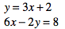
CL 4-116. Solve the system of equations shown at right.

  - Describe what happened when you tried to solve the system.

  - Graph the system of equations. How does the graph of the system explain what happened with the equations?
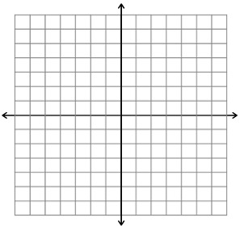

CL 4-118. Solve these systems of equations using any method.
a. y = 3x + 7 b. 3x − y = 17 c. x = 3y − 5
y = −4x + 21 −x + y = −7 2x + 12y = −4

CL 4-119. Bob climbed down a ladder from his roof, while Roy climbed up another ladder next to him. Each ladder had 30 rungs. Their friend Jill recorded the following information about Bob and Roy:
Bob went down 2 rungs every second.
Roy went up 1 rung every second.
At some point, Bob and Roy were at the same height. Which rung were they on?

CL 4-120. Solve for x.
  - 6x − 11 = 4x + 12 b. 2(3x −5) = 6x – 4

c. (x − 3)(x + 4) = x² + 4 d. 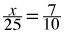

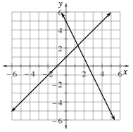
CL 4-122. Leo solved a system of equations by graphing and the graph is shown at right.

  - Estimate the solution from the graph.

  - What is the equation of each line in the system?

  - Solve the system algebraically. How accurate was your estimate?

CL 4-125. Rewrite each expression below as a product and as a sum.
a. (x + 7)(2x − 5) b. 5x(y − 7) c.(3x − 7)(x² − 2x + 11)

