CL 5-126. For each diagram, write an equation and solve to find the value for each variable.
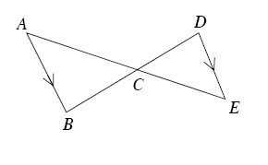
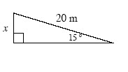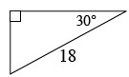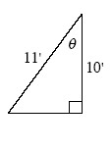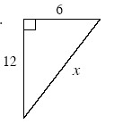
CL 5-127. Copy the diagram at right onto your paper.
Are the triangles similar? If so, show your reasoning with a flowchart.
If mB = 80°, mACB = 29° , AB = 14 , and DE = 12, find CE .
CL 5-129. While working on homework, Zachary was finding the value of each variable in the diagrams below. His first step for each problem is shown under the diagram. If his first step is correct, continue solving the problem to find the solution. If his first step is incorrect, explain his mistake and solve the problem correctly.
a.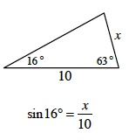 b. 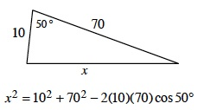

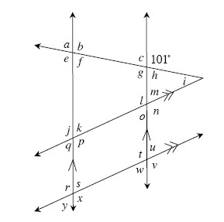
CL 5-130. Examine the diagram at right.
Find the measures of each of all the angles, if possible. If it is not possible, explain why it is not possible. If it is possible, state your reasoning.
If mp = 130° , can you now find the measures of any of the angles from part (a) that you couldn't before? Find the measures for all that you can. Be sure to justify your reasoning.
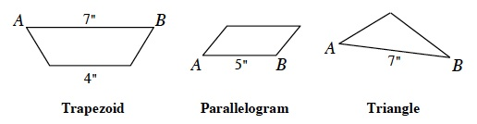
CL 5-131. Trace each figure at right onto your paper. The side labeled is the base in each figure. Then:
- Draw a height for each figure to side .
- Find the area of each figure assuming that the height of each shape is 4" long.
CL 5-132. Bob is hanging a swing from a pole high off the ground so that it can swing a total angle of 120°. Since there is a bush 5 feet in front of the swing and a shed 5 feet behind the swing, Bob wants to ensure that no one will get hurt when they are swinging. What is the maximum length of chain that Bob can use for the swing?
  - Draw a diagram of this situation.
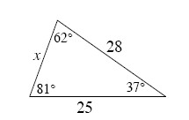
  - What is the maximum length of chain that Bob can use? State what tools you used to solve this problem.
CL 5-133. Examine the triangle at right. Solve for x twice using two different methods.

CL 5-134. Graph the points (3, −4) and (7, 2) on graph paper and draw the line segment and a slope triangle that connects the points. Find:
- The length of the segment
- The slope of the line segment
- The area of the slope triangle
- The measure of the slope angle
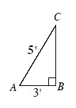
CL 5-135. Trace the figure at right onto your paper and then perform all of the transformations listed below on the same diagram. Then find the perimeter of the final shape.
  - Reflect ΔABC across .
  - Rotate ΔABC 180° around the midpoint of .
  - Reflect ΔABC across .

