Unit 1 Closure 2: WHAT HAVE I LEARNED?

CL A-103. Extend the pattern. Draw Figures 1 and 5 on the paper.
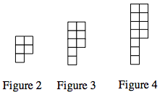
  - How many tiles are in each figure?

  - How is the pattern changing?

  - How many tiles would Figure 6 have?

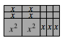
CL A-104. Find the area and perimeter of the figure at right.

CL A-105. Evaluate 6x − (3y + 7) − xy when x = 5 and y = 3. Show all work.

CL A-106. Simplify the expression below by combining like terms:

CL A-107. Solve this equation with our without drawing the algebra tiles. Find x and then show the check:

