- CL 2-123. Sandra's music bag contains:3 CDs of country music
6 CDs of rock and roll
4 CDs of rap music
5 cassette tapes of country music
1 cassette tape of rock and roll
3 cassette tapes of rap music

  - As Sandra drives, she often reaches into her bag and randomly pulls out some music (she does not want to take her eyes off the road). What is the probability that she will select some rap music?
  - Find P(CD), that is, the probability that she will randomly select a CD (of any type of music).
  - Find P(cassette of country music).
  - Find P(not rock and roll), the probability that the music she randomly selects is not rock and roll.
- CL 2-124. Find the area of each figure.

  - 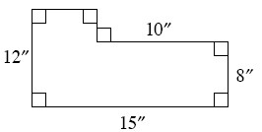
  - 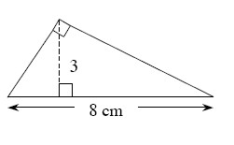
  - 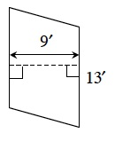
  - 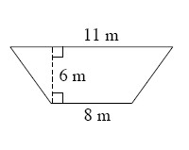

- CL 2-125. Find the perimeter of each figure.

  - 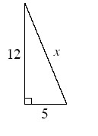
  - 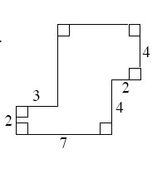

- CL 2-126. Graph the segment that connects the points A(−4, 8) and B(7, 3).
  - What is the slope of ?
  - How long is ?
- CL 2-127. Identify the geometric angle relationship(s) in each diagram. Use what you know about those relationships to write an equation and solve for x.

  - 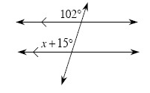
  - 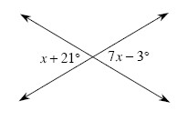
  - 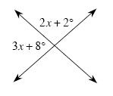
  - 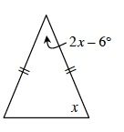

- CL 2-128. Examine the system of equations below.
y = −2x + 6
y = − 9
  - Solve the system below twice: graphically and algebraically. Verify that your solutions from the different methods are the same.
  - What is the relationship between the two lines? How can you tell?
- CL 2-129. Charlotte was transforming the hexagon ABCDEF.
  - What single transformation did she perform in Diagram #1?
    - 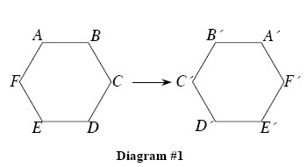
  - What single transformation did she perform in Diagram #2?
    - 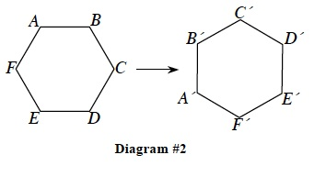
  - What transformation didn’t she do? Write directions for this type of transformation for hexagon ABCDEF and perform it.
- CL 2-130. Explain what you are doing when you find the perimeter of a shape. How is that different than finding the area?
- CL 2-131. Check your answers using the table at the end of this section. Which problems do you feel confident about? Which problems were hard? Have you worked on problems like these in math classes you have taken before? Use the table to make a list of topics you need help on and a list of topics you need to practice more.

