CL 3-103. Each pair of figures below is similar. Find the lengths of all unknown sides.

- 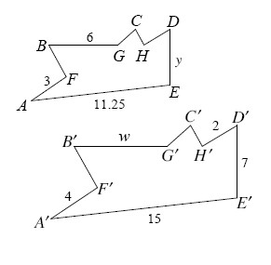
- 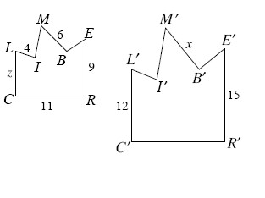

CL 3-104. Draw an example for each geometric term below. Diagrams should be clearly marked with all necessary information. You should also include a brief description of the qualities of each term.
- supplementary angles
- alternate interior angles
- parallel lines
- complementary angle
CL 3-105. Find the perimeter and area of the shape below.
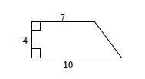
CL 3-106. Create a flowchart that represents the story:
Marcelle and Harpo live at Apt. 1, 8 Logic St. Marcelle took his guitar to band practice across town and isn’t back yet. Harpo hears guitar music in the hallway. He decides that someone else in the building also plays guitar.

CL 3-107. For each pair of triangles below, determine whether or not the triangles are similar. If they are similar, show your reasoning in a flowchart. If they are not similar, explain how you know.

- 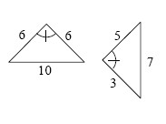
- 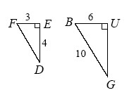
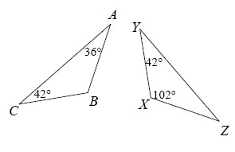

CL 3-108. Use the relationships in the diagrams below to find the values of the variables, if possible. The diagrams are not drawn to scale.

- 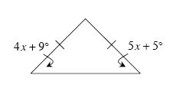
- 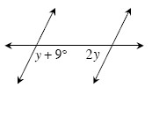
- 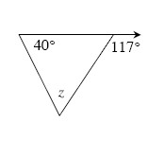

CL 3-109. Among the triangles below are pairs of similar triangles. Find the pairs of similar triangles and state the triangle similarity conjecture that you used to determine that the triangles are similar. Note: The triangles are NOT drawn to scale.
