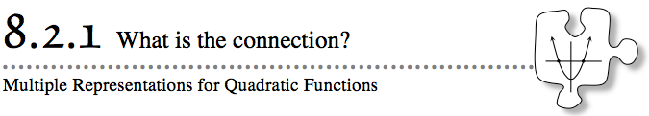
Today you will explore the connections between the different representations for quadratics. As you work, keep in mind the following questions:
What representations are you using?
What is the connection between the various representations?
What do you know about a parabola?
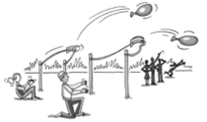
8-55. WATER BALLOON CONTEST
Every year Newtown High School holds a water balloon competition during halftime of their homecoming game. Each contestant uses a catapult to launch a water balloon from the ground on the football field. This year you are the judge! You must decide which contestants win the prizes for Longest Distance and Highest Launch. Fortunately, you have a computer that will collect data for each throw. The computer uses x to represent horizontal distance in yards from the goal line and y to represent the height in yards.
The announcer shouts, “Maggie Nanimos, you’re up first!” She runs down and places her catapult at the 3-yard line. After Maggie’s launch, the computer reports that the balloon traveled along the parabola represented by the quadratic equation y = −x² + 17x − 42.
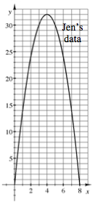

Then you hear, “Jen Erus, you’re next!” Jen runs down to the field, places her catapult at the goal line, and releases the balloon. The tracking computer reports the path of the balloon with the graph at right.

The third contestant, Imp Ecable, accidentally launches the balloon before you are ready. The balloon launches, you hear a roar from the crowd, turn around, and…SPLAT! The balloon soaks you and your computer! You only have time to write down the following partial information about the balloon’s path before your computer fizzles:
x (yards) | 2 | 3 | 4 | 5 | 6 | 7 | 8 | 9
y (yards) | 0 | 9 | 16 | 21 | 24 | 25 | 24 | 21
Finally, the announcer calls for the last contestant, Al Truistic. With your computer broken, you decide to record the balloon's height and distance by hand. Al releases the balloon from the 10-yard line. The balloon reaches a height of 27 yards and lands at the 16-yard line.

  - Obtain the Lesson 8.2.1A Resource Page from your teacher. For each contestant, create a table and graph using the information provided for each toss. Determine which of these contestants should win the Longest Distance and Highest Throw contests.

  - Find the x-intercepts of each parabola. What information do the x-intercepts tell you about each balloon toss?
  - Find the vertex of each parabola. What information does the vertex tell you about each balloon throw?
  - What is the domain and range of Maggie’s parabola?
  - Where is the line of symmetry for Maggie’s parabola?
- 8-56. SITUATION TO RULE
Write an explicit equation from the situation described by the tile pattern below.
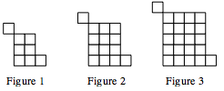
- Write a rule to represent the number of tiles in Figure x.
- Is the rule from part (a) quadratic? Explain how you know.

