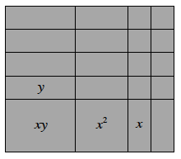
In Chapter 3 you learned how to multiply algebraic expressions using algebra tiles and generic rectangles. This section will focus on reversing this process: How can you find a product when given a sum?
8-1. Review what you know about products and sums below.
  - Write the area of the rectangle at right as a product and as a sum. Remember that the product represents the area found by multiplying the length by the width, while the sum is the result of adding the areas inside the rectangle.

  - Use a generic rectangle to multiply (6x − 1)(3x + 2). Write your solution as a sum.

8-2. The process of changing a sum to a product is called factoring. Can every expression be factored? That is, does every sum have a product that can be represented with tiles?
Investigate this question by building rectangles with algebra tiles for the following expressions. For each one, write the area as a product. If you cannot build a rectangle, be prepared to convince the class that no rectangle exists (and thus the expression cannot be factored).
  - 2x² + 7x + 6
  - 6x² + 7x + 2
  - x² + 4x + 1
  - 2xy + 6x + y² + 3y
8-3. Work with your team to find the sum and the product for the following generic rectangles. Are there any special strategies you discovered that can help you determine the dimensions of the rectangle? Be sure to share these strategies with your teammates.
  - 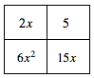 b. 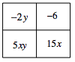 c. 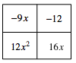

8-4. While working on problem 8-3, Casey noticed a pattern with the diagonals of each generic rectangle. However, just before she shared her pattern with the rest of her team, she was called out of class! The drawing on her paper looked like the diagram below. Can you figure out what the two diagonals have in common?
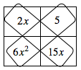

8-5. Does Casey’s pattern always work? Verify that her pattern works for all of the 2-by-2 generic rectangles in problem 8-3. Then describe Casey’s pattern for the diagonals of a 2-by-2 generic rectangle in your Learning Log. Be sure to include an example.
  - b. c.

8-5. Does Casey’s pattern always work? Verify that her pattern works for all of the 2-by-2 generic rectangles in problem 8-3. Then describe Casey’s pattern for the diagonals of a 2-by-2 generic rectangle in your Learning Log. Be sure to include an example.
  - b. c.

