Algebra II CP – Unit 1 Day 1 HW Name: __________________
- 1-52. Find the error in the solution below. Identify the error and solve the equation correctly.
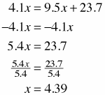

- 1-53. Solve each of the following equations.
  - 3.9x − 2.1 = 11.2x + 51.7 b. 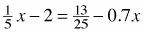

- 1-72. Rearrange each equation below by solving for x. Write each equation in the form x = ____. (Note that y will be in your answer).
- 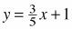 b. 3x + 2y = 6

- 1-95. Salami and More Deli sells a 5-foot submarine sandwich for parties. It weighs 8 pounds. Assuming that the weight per foot is constant, what would be the length of a 12-pound sandwich?

- 1-108. Jason loves to download music. Downloads R Us sells songs only in packages of three, and it charges $2.00 for each package of three songs. Jason's favorite group just released their Greatest Hits CD, which has 17 songs on it. Jason wants to buy all 17 songs from Downloads R Us. How much should Jason expect to pay?

