9-19. Mrs. Billings is designing a home. She found the plan for his dream house on the Internet. 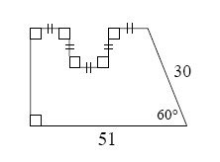
- The design of the home is shown above. If all measurements are in millimeters, find the area of the diagram.
b. Mrs. Billings took her home design to the copier and enlarged it 400%. What is the area of the diagram now? Show how you know.

9-21. Review what you know about the angles of polygons below.
- If the exterior angle of a polygon is 29°, what is the interior angle?
- If the interior angle of a polygon is 170°, can it be a regular polygon? Why or why not?
- Find the sum of the interior angles of a regular 29-gon.

9-22. For each geometric relationship represented below, write and solve an equation for x. Show all work.
- 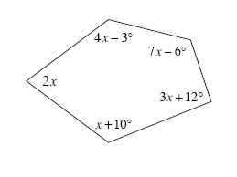b.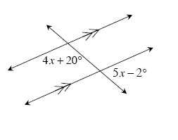

9-24. Multiple Choice: Find the perimeter of the sector at right.
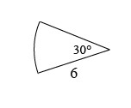
a. 12units | b. 3 units | c. 6 + 3 units | d. 12 + units | e. None of these

9-29. In the diagram below, is a midsegment of ΔABC. If the area of ΔABC is 96 square units, what is the area of ΔADE?
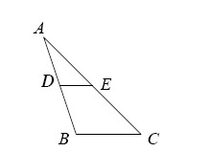

9-30. Draw a rectangular prism as neatly as possible on your paper. If the width is 9 cm, the height is 14 cm, and the depth is 7 cm, find the surface area and volume.

