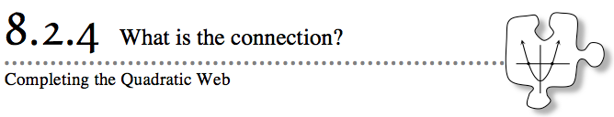
Today you will focus on how to get a quadratic equation from a table, graph, and a situation. As you work, ask yourself the following questions:
Which representation am I given?
Which representation am I looking for?
How can I reverse this process?
Is there another way?
- 8-89. TABLE TO RULE
You know how to make a table for a quadratic rule, but how can you write an equation when given the table? Examine this new connection that requires you to reverse your understanding of the Zero Product Property as you find a rule for each table below. What clues in the tables helped you find the rule? How can you check your equation using your graphing calculator?
  - 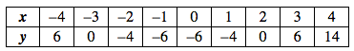

  - 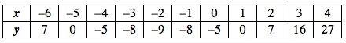

- 8-90. QUALITY CONTROL, Part One
Congratulations! With your promotion, you are now the Quality Assurance Representative of the Function Factory. Your job is to make sure your clients are happy. Whenever a client writes to the company, you must reply with clear directions that will solve his or her problem.
Your boss has provided graphing technology and a team of fellow employees to help you fulfill your job description.
- Your Task:
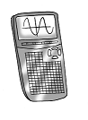
- Carefully read the complaints below. Use your graphing calculator to study each situation. Work with your team to resolve each situation.
- Write each customer a friendly response that offers a solution to his or her problem. Remember that the customers are not parabola experts! Do not assume that they know anything about parabolas.
