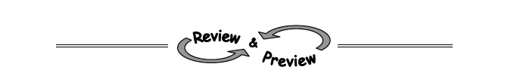
5-46. Allie is making 8-dozen chocolate-chip muffins for the Food Fair at school. The recipe she is using makes 3-dozen muffins. If the original recipe calls for 16 ounces of chocolate chips, how many ounces of chocolate chips does she need for her new amount? (Allie buys her chocolate chips in bulk and can measure them to the nearest ounce.)
5-53. Solve each system.
  - y + 3x = −10
5x − y = 2
  - 6x = 7 − 2y
4x + y = 4
5-54. Draw a slope triangle and use it to find the equation of the line shown in the graph below.
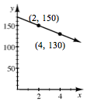

7-8. If two expressions are equivalent, they can form an equation that is considered to be always true. For example, since 3(x − 5) is equivalent to 3x −15, then the equation 3(x − 5) = 3x − 15 is always true, that is, true for any value of x.
- If two expressions are equal only for certain values of the variable, they can form an equation that is considered to be sometimes true. For example, x + 2 is equal to 3x − 8 only when x = 5, so the equation x + 2 = 3x − 8 is said to be sometimes true.
- If two expressions are not equal for any value of the variable, they can form an equation that is considered to be never true. For example, x − 5 is not equal to x + 1 for any value ofx, so the equation x − 5 = x + 1 is said to be never true.
- Is the equation (x + 3)² = x² + 9 always, sometimes or never true? Justify your reasoning completely.

7-9. Consider the sequence that begins 40, 20, 10, 5, …
  - Based on the information given, can this sequence be arithmetic? Can it be geometric? Why?
  - Assume this is a geometric sequence. On graph paper, plot the sequence on a graph up to n = 6.
  - Will the values of the sequence ever become zero or negative? Explain.

7-10. If a ball is dropped from 160 cm and rebounds to 120 cm on the first bounce, how high will the ball be:
  - On the 2nd bounce?
  - On the 5th bounce?
  - On the n^{th} bounce?

