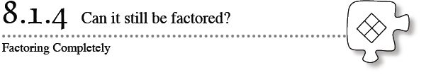
There are several ways to write the number 12 as a product of factors. For example, 12 can be rewritten as 3 · 4, as 2 · 6, as 1 · 12, or as 2 · 2 · 3. While each of these products is accurate, only 2 · 2 · 3 is considered to be factored completely, since the factors are prime and cannot be factored themselves.
During this lesson you will learn more about what it means for a quadratic expression to be factored completely.
8-35. Review what you have learned by factoring the following expressions, if possible.
  - 9x² − 12x + 4
  - 81m² – 1
  - 28 + x² − 11x
  - 3n² + 9n + 6

8-36. Compare your solutions for problem 8-35 with the rest of your class.
  - Is there more than one factored form of 3n² + 9n + 6? Why or why not?

  - Why does 3n² + 9n + 6 have more than one factored form while the other quadratics in problem 8-35 only have one possible answer? Look for clues in the original expression (3n² + 9n + 6) and in the different factored forms.

  - Without factoring, predict which quadratic expressions below may have more than one factored form. Be prepared to defend your choice to the rest of the class.
    - 12t² − 10t + 2
    - 5p² − 23p − 10
    - 10x² + 25x − 15
    - 3k² + 7k – 6
8-37. FACTORING COMPLETELY
In part (c) of problem 8-36, you should have noticed that each term in 12t² − 10t + 2 is divisible by 2. That is, it has a common factor of 2.
  - An expression is considered completely factored if none of the factors can be factored any more. Often it is easiest to remove common factors first, before factoring with a generic rectangle. Rewrite this expression 10x² + 25x − 15 with the common factor factored out.
  - Your result in part (a) is not completely factored if either factor can be factored. Factor 10x² + 25x − 15 completely.
8-38. Factor each of the following expressions as completely as possible.
  - 5x² + 15x – 20
  - 3x³− 6x² − 45x
  - 2x² – 50
  - x²y − 3xy − 10y

