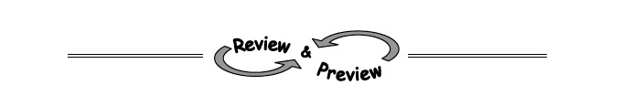
5-69. Solve the system below for m and b.
1239 = 94m + b
810 = 61m + b

7-24. Each table below represents an exponential function of the form y = ab^{x} . Copy and complete each table on your paper and find the corresponding equation.
  - 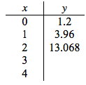 b.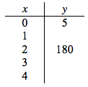

7-25. Brianna is working on her homework. Her assignment is to come up with four representations for an exponential function of her choosing. She decides it is easiest to start by writing an equation, so she chooses 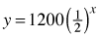. Help Brianna create the other three components of the web.

7-27. Write an equation or system of equations to solve this problem.
Morgan started the year with $615 in the bank and is saving $25 per week. Kendall started with $975 and is spending $15 per week. When will they both have the same amount of money in the bank?

