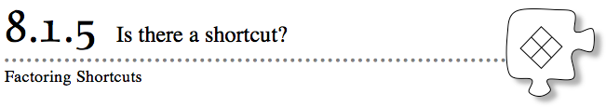
Are there any types of quadratic expressions that you can factor quickly without using a generic rectangle? If so, what do these quadratics look like and how can you recognize them? Today your team will examine the factored forms of several different quadratic expressions and look for patterns and shortcuts for factoring them.
8-45. SPECIAL QUADRATICS
Your team will be assigned several of the quadratic expressions below to factor (if possible). Look for similarities and differences among the expressions and their corresponding factored forms. Be prepared to share your factored results with the class. Then work as a class to sort them into groups based on the patterns you find in their factored forms.
  - x² − 49
  - x² + 2x − 24
  - x² − 10x + 25
  - 9x² + 12x + 4
  - 5x² − 4x − 1
  - 4x² − 25
  - x² − 6x + 9
  - x² − 36
  - 7x² − 20x − 3
  - 4x² + 20x + 25
  - x² + 4
  - 9x² – 1

8-46. Which of the following quadratic expressions fit the patterns you found in problem 8-45? Factor each of the following expressions using your new shortcuts, if possible.
  - 25x² – 1
  - x² − 5x – 36
  - x² + 8x + 16
  - 9x² − 12x + 4
  - 9x² + 4
  - 9x² − 100

8-47. Special quadratics expressions, like 9x² − 100 in part (f) of problem 8-46, can be factored quickly once you discover the pattern. But why do the patterns you found in problem 8-45 work?
  - A quadratic expression in the form a²x² − b² is called a difference of squares. Use a generic rectangle to prove that a²x² − b² = (ax − b)(ax + b). Be ready to share your work with the class.
  - A quadratic expression in the form a²x² + 2abx + b² is called a perfect square trinomial. Use a generic rectangle to prove that a²x² + 2abx + b² = (ax + b)². Be ready to share your work with the class.

Exit Slip:
Describe how to factor a difference of squares and a perfect square trinomial. Be sure to include an example of each type.

Exit Slip:
Describe how to factor a difference of squares and a perfect square trinomial. Be sure to include an example of each type.

