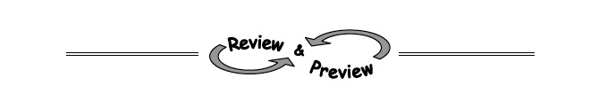5-78. Draw a slope triangle and use it to find the equation of the line shown in the graph at right.
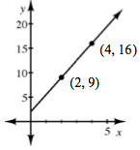

5-79. Find the following products.
  - (4x + 5)(4x – 5)

  - (4x + 5)²

5-80. Write an equation or system of equations to solve the problem below
Apollo and Zeus are both on diets. Apollo currently weighs 105 kg and is gaining 2 kg per month. Zeus currently weighs 130 kg and is losing 3 kg per month. In how many months will they weigh the same?

7-35. Your banker shows you the graph at right to explain what you can earn if you invest with him. Does this graph represent simple or compound interest? How can you tell? Write an equation to represent how much money you would have as time passes. Make sure you write a “let” statement.
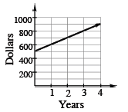

7-36. Each table below represents an exponential function in y = ab^{x} form. Copy and complete each table on your paper and find a corresponding equation.
  - 
   