Name: _______________________

How to study for a math final….

- Go through your old homework and class notes from the semester and remind yourself of the concepts we have been working on.
- Analyze your strengths and weakness, so you know where to focus your study time.
- Come to class with questions about concepts that are still fuzzy.
- Sharpen your pencils, find your big pink eraser, and get some paper and PRACTICE.
- Your teachers are happy to help you. Seek us out before, after and during the school day. We have time to answer your questions one-on-one, if that is what you need.
- Use the internet! Start with cpm.org – there is a lot of extra practice –especially homework help. You can also google topics, like “quadratic formula” for videos, tutorials and extra practice.

Solve for x in the equations below

1. 2x − 5(x + 4) = 1 2. 6x − 11 = 4x + 12

3. 2(3x − 5) = 6x – 4 4. 5 – 2x = 37

Solve the following by factoring and using the zero product property
5. 0 = x² − 7x + 12 6. 0 = x² – 9

Analyze characteristics of linear functions

1. Consider the following graph.
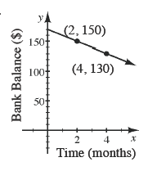
- What real world quantities do the slope and y-intercept represent?

- What is the rate change?

- Write the equation of the line that represents the equation.

2. Find the slope, y-intercept and x-intercept in the following equations.
a. y = 2x + 1 b. y = − 4 c 3x + 2y = 4

3. Find the rule for the following tile pattern.
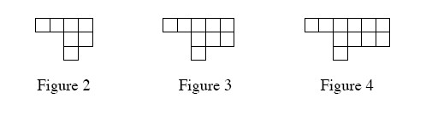

1. Hypatia wants to use the elimination method to solve the system of equations below. She thinks that a variable will be eliminated if she multiplies the first equation by –1 and then adds the equations together. Is she correct? If so use her method to solve the equation. Otherwise Explain why her idea will not work.

x + 2y = 8
y + x = 5

Solve the following systems of equations using any method shown above
2. y = 3x + 7  y = −4x + 21 | - x = 3y − 5  2x + 12y = −4

3. Help! I need to rent a car on my next business trip! One company, Mertz, charges $35 plus $20 per day. The second company, Cheapo, charges $15 plus $25 per day.

a. Write an expression for each company to show the relationship between the total cost and the number of days.

MERTZ:__________________________________________

CHEAPO:__________________________________________

b. Find out when both costs are the same

c. I will need the car for one week. Which company should I rent from?

Slope = $\frac{RISE}{RUN}$ $\frac{∆y}{∆x}$ $\frac{y_{2 }- y_{1}}{x_{2}-x_{1}}$
1. Find the slope of the line passing through each pair of points below.
- (1, 2) and (4, −1) B. (55, 67) and (50, 68) C. (−6, 8) and (−8, 5)

2. Three points are named on the line at the right.
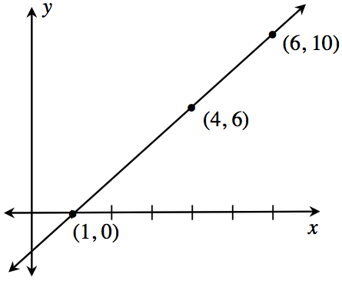
a. Find three more points that lie on the line to the right. Show or explain how you found your answer.

b. Find a rule for your line. Show or explain how you and your group determined the rule.

c. Verify your rule is correct using the three original points.

1. Complete the table below for the rule y = x² - 4.

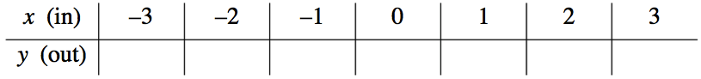

2. Graph the points.

3. Determine the important characteristics of the above graph.

a. axis of symmetry x = ______
b. vertex ( , )
c. y-intercept ( , )
d. x-intercepts ( , ) & ( , )

1. Solve the quadratic equation using both the Zero Product Property and the Quadratic Formula. Did the solutions match? If not, why not?

2. Use the table below to write a quadratic rule. Explain how you created your equation.

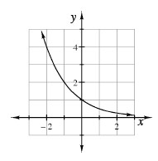

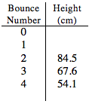
1. Arnold dropped a ball during the bouncing ball activity and recorded its height in a table. Part of his table is shown at right. What was the rebound ratio of his ball? At what height did he drop the ball? Write an equation that represents his data. Explain your equation.

2. Every minute a computer sends a virus to 5 new computers. The following minute the original computer sends its virus to 5 new computers, and each computer that received it the first minute sends it to 5 more. This pattern continues until someone figures out how to stop it.

a. Create a diagram, a table, and an equation to represent this situation.

b. How many computers will have the virus after 10 minutes (if no one has stopped it)? How can you tell?

3. The number of bacteria in a Petri dish triple every month. If the dish started with 250 bacteria, how many will there be in 10 months? How do you know?

