Polygons
A polygon is defined as a two-dimensional closed figure made up of straight line segments connected end-to-end. These segments may not cross (intersect) at any other points.
Below are some examples of polygons.
Shape A below is an example of a regular polygon because its sides are all the same length and its angles have equal measure.
- 1-100. Solve the equations below for x, if possible. Be sure to check your solution.
  - (5 − x)(2x + 3) = 0
  - 6 − 5(2x − 3) = 4x + 7
- 1-102. Copy ΔABC below on graph paper.
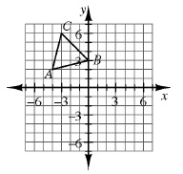
  - Rotate ΔABC 90° counter-clockwise () about the origin to create ΔA′B′C′. Name the coordinates of C′ .
  - Reflect ΔABC across the vertical line x = 1 to create A″B″C″ .
  - Translate ΔABC so that A′″ is at (4, −5). Name the coordinates of B′″ .

- 1-110. If no sides of a triangle have the same length, the triangle is called scalene. However, if the triangle has two sides that are the same length, the triangle is called isosceles. Use the markings in each diagram below to decide if ΔABC is isosceles or scalene. Assume the diagrams are not drawn to scale.
 | a.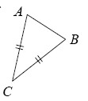 | b.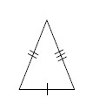 | c.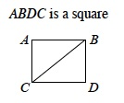
- 1-112. Without referring to your Shapes Toolkit, see if you can recall the names of each of the shapes below. Then check your answers with definitions from your Shapes Toolkit. How did you do?
 | a. 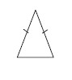 | b. 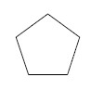 | c. 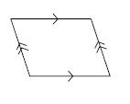
 | d. 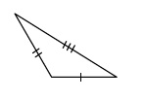 | e. 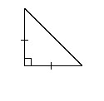 | f. 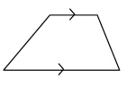
- 1-114. Multiple Choice: Which equation below correctly represents the relationship of the sides given in the diagram below?
  - 3x − 2 + 2x + 17 = 360°
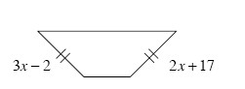
  - 3x − 2 + 2x + 17 = 180°
  - 3x − 2 + 2x + 17 = 90°
  - 3x − 2 = 2x + 17

