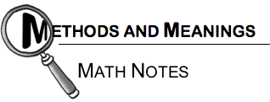

The Perimeter and Area of a Figure
The perimeter of a two- dimensional figure is the distance around its exterior (outside) on a flat surface. It is the total length of the boundary that encloses the interior (inside) region. See the example at right. | 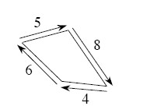  Perimeter = 5 + 8 + 4 + 6 = 23 units
The area indicates the number of square units needed to fill up a region on a flat surface. For a rectangle, the area is computed by multiplying its length and width. The rectangle below has a length of 5 units and a width of 3 units, so the area of the rectangle is 15 square units. | 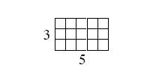  Area = 5 · 3 = 15 square units

- 1-15. The shapes below are examples of equilateral triangles. How can you describe an equilateral triangle? Make at least two statements that seem true for all equilateral triangles. Then trace these equilateral triangles on your paper and draw one more in a different orientation.
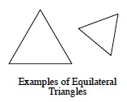
- 1-16. Match each table of data below with the most appropriate graph and briefly explain why it matches the data.
  - Boiling water cooling down.
Time (min) | 0 | 5 | 10 | 15 | 20 | 25
Temp (˚C) | 100 | 89 | 80 | 72 | 65 | 59

  - Cost of a phone call.
Time (min) | 1 | 2 | 2.5 | 3 | 4 | 5 | 5.3 | 6
Cost (cents) | 55 | 75 | 75 | 95 | 115 | 135 | 135 | 135

Age (months) | 1 | 2 | 3 | 4 | 5 | 6 | 7 | 8 | 9
Length (inches) | 0.75 | 1.5 | 3 | 6.4 | 9.6 | 12 | 13.6 | 15.2 | 16.8

  - Growth of a baby in the womb.

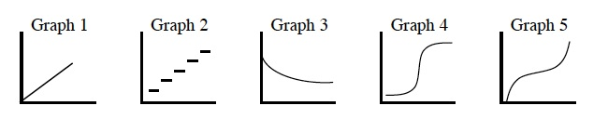
- 1-17. Solve for the given variable. Show the steps leading to your solution. Check your solution.
  - a. −11x = 77 b. 5c + 1 = 7c − 8
c. d. −12 = 3k + 9

- 1-26. Delilah drew 3 points on her paper. When she connects these points, must they form a triangle? Why or why not? Draw an example on your paper to support your reasoning.

- 1-27. Copy the table below onto your paper. Complete it and write a rule relating x and y.
x | 3 | -1 | 0 | 2 | -5 | -2 | 1
y | 0 |  |  | -1 |  |  | -2

- 1-29. Evaluate each expression below if a = −2 and b = 3.
a. 3a² − 5b + 8 b. c.

