Solving Linear Equations
In Algebra, you learned how to solve a linear equation. This course will help you apply your algebra skills to solve geometric problems. Review how to solve equations by reading the example below.

- Simplify. Combine like terms on each side of the equation whenever possible. | 3x − 2 + 4 = x − 6 | Combine like terms
 | 3x + 2 = x − 6
 | −x = −x | Subtract x on both sides
- Keep equations balanced. The equal sign in an equation tells you that the expressions on the left and right are balanced. Anything done to the equation must keep that balance. | 2x + 2 = −6
 | −2 = −2 | Subtract 2 on both sides
 |  | Divide both sides by 2
 | x = −4
- Move your x-terms to one side of the equation. Isolate all variables on one side of the equation and the constants on the other.
- Undo operations. Use the fact that addition is the opposite of subtraction and that multiplication is the opposite of division to solve for x. For example, in the equation 2x = −8 , since the 2 and the x are multiplied, then dividing both sides by 2 will get x alone.
- 1-32. One goal of this course will be to review and enhance your algebra skills. Read the Math Notes box for this lesson. Then solve for x in each equation below, show all steps leading to your solution, and check your answer.
a. 34x − 18 = 10x – 9 b. 4x − 5 = 4x + 10

c. 3(x − 5) + 2(3x + 1) = 45 d. −2(x + 4) + 6 = −3

- 1-34. For each of the equations below, solve for y in terms of x.
a. 2x − 3y = 125 b. x + 2y = 7

- 1-35. Find the area of the rectangle below. Be sure to include units in your answer.
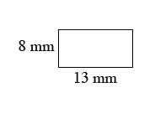
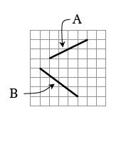
- 1-36. The slope of a line is a measure of its steepness and indicates whether it goes up or down from left to right. For example, the slope of the line segment A at right is , while the slope of the line segment B is . For each line segment below, find the slope. You may want to copy each line segment on graph paper in order to draw slope triangles.
  - a. b. c. d.
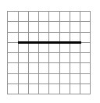
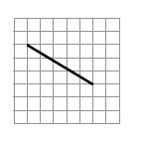
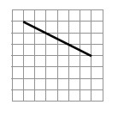
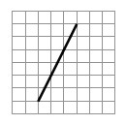

- 1-42. Estimate the size of each angle below to the nearest 10°. A right angle is shown for reference so you should not need a protractor.
a. b. c.
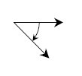
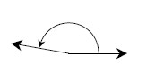
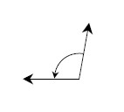

- 1-44. Angela had a rectangular piece of paper and then cut a rectangle out of a corner as shown below. Find the area and perimeter of the resulting shape. Assume all measurements are in centimeters.
