Graphing an Equation
x | −4 | −3 | −2 | −1 | 0 | 1 | 2 | 3 | 4
y | 2 | 1 | 0 | −1 | −2 | −3 | −4 | −5 | −6
In Algebra, you learned how to graph an equation. During this course, you will apply your algebra skills to solve geometric problems. Review how to graph an equation by reading the example below.
- Create a table of x-values. Choose x-values that will show you any important regions of the graph of the equation. If you do not know ahead of time what the graph will look like, use the values −4 < x < 4 as shown below.
y = −x − 2
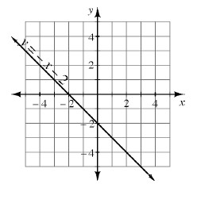
- Use the equation to find y-values. Substitute each value of x into your equation and find the corresponding y-value. For example, for y = −x − 2, when x = −3, y = −(−3) −2 = 1.
- Graph the points using the coordinates from your table onto a set of x → y axes. Connect the points and, if appropriate, use arrows to indicate that the graph of the equation continues in each direction.
- Complete the graph. Be sure your axes are scaled and labeled. Also label your graph with its equation as shown in the example above.
- 1-64. Decide which transformation was used on each pair of shapes below. Some may have undergone more than one transformation.
a. b. c.
a
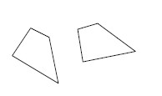
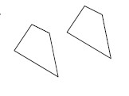
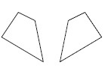

d. e. f.
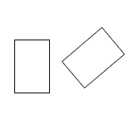
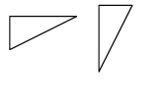
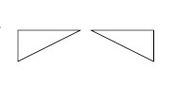

- 1-65. The perimeter (the sum of the side lengths) of the triangle at right is 52 units. Write and solve an equation based on the information in the diagram. Use your solution for x to find the measures of each side of the triangle. Be sure to confirm that your answer is correct
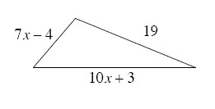
- 1-67. For each equation below, find y if x = −3.
  - y = −x − 5
  - y = 2x² − 3x − 2
  - 2x − 5y = 4

- 1-74. Solve for the variable in each equation below. Show the steps leading to your answer.
  - 8x − 22 = −60
  - 9a +15 = 10a – 7

- 1-75. Graph the rule on graph paper. Label the points where the line intersects the x and y axes.

- 1-76. On graph paper, graph the line through the point (0, −2) with slope . Write the equation of the line.
a. Translate the graph of the line up 4 and to the right 3 units. What is the result? Write the equation for the resulting line.
b. Now translate the original graph down 5 units. What is the result? Write the equation for the resulting line.

