Slope of a Line and Parallel and Perpendicular Slopes
During this course, you will use your algebra tools to learn more about shapes. One of your algebraic tools that can be used to learn about the relationship of lines is slope. Review what you know about slope below.
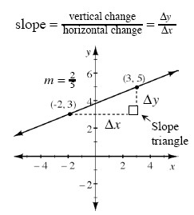
The slope of a line is the ratio of the change in y (Δy) to the change in x (Δx) between any two points on the line. It indicates both how steep the line is and its direction, upward or downward, left to right.
Lines that point upward from left to right have positive slope, while lines that point downward from left to right have negative slope. A horizontal line has zero slope, while a vertical line has undefined slope. The slope of a line is denoted by the letter m when using the y = mx + b equation of a line.
One way to calculate the slope of a line is to pick two points on the line, draw a slope triangle (as shown in the example above), determine Δy and Δx, and then write the slope ratio. Be sure to verify that your slope correctly resulted in a negative or positive value based on its direction.
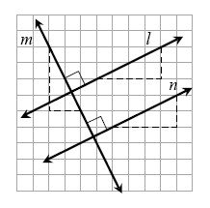
Parallel lines lie in the same plane (a flat surface) and never intersect. They have the same steepness, and therefore they grow at the same rate. Lines l and n below are examples of parallel lines.
On the other hand, perpendicular lines are lines that intersect at a right angle. For example, lines m and n above are perpendicular, as are lines m and l. Note that the small square drawn at the point of intersection indicates a right angle.
The slopes of parallel lines are the same. In general, the slope of a line parallel to a line with slope m is m.
The slopes of perpendicular lines are opposite reciprocals. For example, if one line has slope , then any line perpendicular to it has slope . If a line has slope −3, then any line perpendicular to it has slope . In general, the slope of a line perpendicular to a line with slope m is .
1-92. On graph paper, graph each of the lines below on the same set of axes. What is the relationship between lines (a) and (b)? What about between (b) and (c)?
  - y = + 4
  - y = −3x + 4
  - y = −3x – 2

1-93. The length of a side of a square is 5x + 2 units. If the perimeter is 48 units, complete the following.
a. Write an equation to represent this information.
b. Solve for x.
c. What is the area of the square?
1-94. When the shapes below are reflected across the given line of reflection, the original shape and the image (reflection) create a new shape. For each reflection below, name the new shape that is created.
a. b. c.
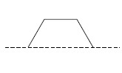
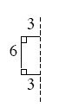
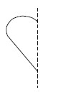

d. Use this method to create your own shape that has reflection symmetry. Add additional lines of symmetry. Note that the dashed lines of reflection in the figures above become lines of symmetry in the new shape.
1-95. If a triangle has two equal sides, it is called isosceles (pronounced eye-SOS-a-lees). “Iso” means “same” and “sceles” is related to “scale.” Decide whether each triangle formed by the points below is isosceles. Explain how you decided.
a. (6, 0), (0, 6), (6, 6) b. (−3, 7), (−5, 2), (−1, 2) c. (4, 1), (2, 3), (9, 2) d. (1, 1), (5, −3), (1, −7)
- 1-96. Copy the diagrams below on graph paper. Then find each result when each indicated transformation is performed.
a. Reflect A across line l. b. Rotate B 90° counterclockwise () about point P.
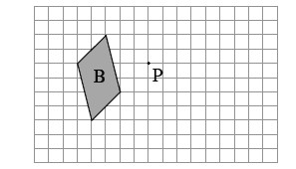
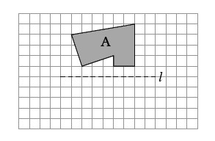

c. Rotate C 180° about point Q. d. Reflect D across line m.
