2-101. Draw the triangle below on graph paper. Then draw a square on and use it to find the length of .
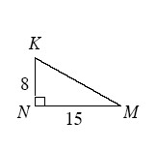
2-102. Examine the rectangle below.
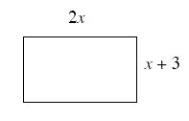
- What is the perimeter in terms of x? In other words, find the perimeter.
- If the perimeter is 78 cm, find the dimensions of the rectangle. Show all your work.
- Verify that the area of this rectangle is 360 sq. cm. Explain how you know this.
2-103. Examine the arrow diagram below.
Polygon is a parallelogram → area of the polygon equals base times height.
- Write this conjecture as a conditional (“If, then”) statement.
- Write a similar conjecture about triangles, both as a conditional statement and as an arrow diagram.

2-110. Write the equation of each line described below in slope-intercept form (y = mx + b).
- m = and b = −3
- m = and b = 4.5
- m = and the line passes through the origin (0, 0)
- m = 0 and b = 2

