2-111. Examine the diagram below. Based on the information in the diagram, which angles can you determine? Copy the diagram on your paper and find only those angles that you can justify.
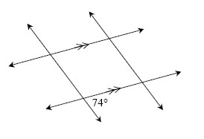
2-112. Hannah’s shape bucket contains an equilateral triangle, an isosceles right triangle, a regular hexagon, an isosceles trapezoid, a rhombus, a kite, a parallelogram and a rectangle. If she reaches in and selects a shape at random, what is the probability that that the shape will meet the criterion described below?
- At least two sides congruent.
- Two pairs of parallel sides.
- At least one pair of parallel sides.
2-113. On graph paper, plot ABCD if A (−1, 2), B (0, 5), C (2, 5), and D (6, 2).
- What type of shape is ABCD? Justify your answer.
- If ABCD is rotated 90° counterclockwise () about the origin, name the coordinates of the image A′B′C′D′.
- On your graph, reflect ABCD across the y -axis to find A″B″C″D″. Name the coordinates of A″ and C″.
- Find the area of ABCD. Show all work.

2-120. Find the area of the trapezoid below. What strategies did you use?
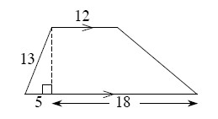

2-122. Find the minimum and maximum limits for the length of a third side of a triangle if the other two sides are 8″ and 13″.

