• 2-19. In problem 2-11, you determined that because an isosceles triangle has reflection symmetry, then it must have two angles that are congruent.
- How can you tell which angles are congruent? For example, in the diagram at below, which angles must have equal measure? Name the angles and explain how you know.
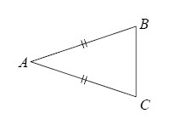
- Examine the diagram for part (a). If you know that mB + mC = 124°, then what is the measure of B? Explain how you know.
- Use this idea to find the value of x in the diagram below. Be sure to show all work.
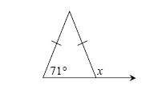
- 2-31. Looking at the diagram below, John says that mBCF = mEFH.
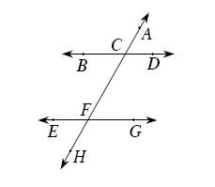
  - Do you agree with John? Why or why not?
  - Jim says, “You can't be sure those angles are equal. An important piece of information is missing from the diagram!” What is Jim talking about?

Note:
This stoplight icon will appear periodically throughout the text. Problems with this icon display common errors that can be made. Be sure not to make the same mistakes yourself!
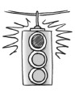
- 2-32. Use your knowledge of angle relationships to solve for x in the diagrams below. Justify your solutions by naming the geometric relationship.
  - 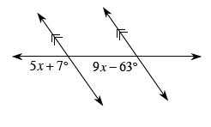
  - 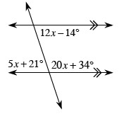
- 2-33. On graph paper, draw line segment if A (6, 2) and B (3, 5).
  - Reflect across the line x = 3 and connect points A and A′. What shape is created by this reflection? Be as specific as possible.
  - What polygon is created when is reflected across the line y = −x + 6 and all endpoints are connected to form a polygon?

