• 2-38. Find all missing angles in the diagrams below.

- 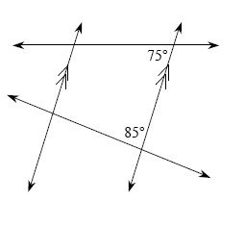
- 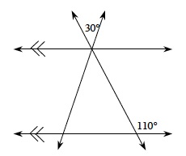

• 2-39. Robert believes the lines graphed below are perpendicular, but Mario is not convinced. Find the slope of each line, and explain how you know whether or not the lines are perpendicular.
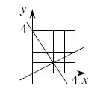
• 2-51. Solve for x in the diagram below.
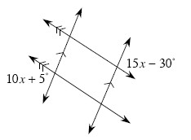

• 2-52. For each diagram below, set up an equation and solve for x.
- Perimeter = 76 units

 