2-54. Graph the line y = on graph paper.
- Draw a slope triangle.

- Rotate your slope triangle 90° around the origin to get a new slope triangle. What is the new slope?

- Find the equation of a line perpendicular to y = .

• 2-63. Examine the triangle below.
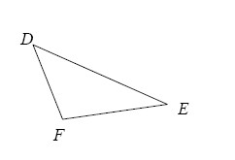
- If mD = 48° and mF = 117°, then what is mE?
- Solve for x if mD = 4x + 2°, mF = 7x − 8°, and mE = 4x + 6°. Then find mD.
- If mD = mF = mE, what type of triangle is ΔFED?

• 2-64. Plot ΔABC on graph paper if A (6, 3), B (2, 1), and C (5, 7).
- ΔABC is rotated about the origin 180° to become ΔA′B′C′. Name the coordinates of A′, B′, and C′.
- This time ΔABC is rotated 180° about point C to form ΔA″B″C″. Name the coordinates of B″.
- If ΔABC is rotated 90° clockwise () about the origin to form ΔA′″B′″C′″, what are the coordinates of point A′″?

• 2-65. Examine the graph below.
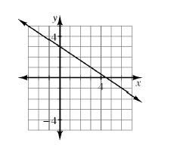
- Find the equation of the line.

- Is the line y = + 1 perpendicular to this line? How do you know?

