• 2-70. Review how to multiply binomials by reading the Math Notes box for this lesson. Then rewrite each of the expressions below by multiplying binomials and simplifying the resulting expression.
- (4x + 1)(2x − 7)
- (−3x + 1)(2x − 5)
• 2-71. The shaded triangle below is surrounded by a rectangle. Find the area of the triangle.
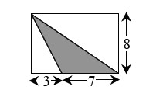
• 2-72. For each diagram below, solve for x. Explain what relationship from your Angle Relationships Toolkit you used for each problem.
- 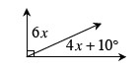
- 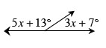
- 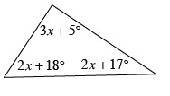
- 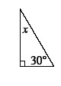

• 2-74. What is the probability of drawing each of the following cards from a standard playing deck? Remember that a standard deck of cards includes: 52 cards of four suits. Two suits are black: clubs and spades; two are red: hearts and diamonds. Each suit has 13 cards: 2 through 10, Ace, Jack, Queen, and King.
- P(Jack)
- P(spade)
- P(Jack of spades)
- P(not spade)

