Angle Relationships
If two angles have measures that add up to 90°, they are called complementary angles. For example, in the diagram at right, ABC and CBD are complementary because together they form a right angle.

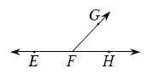
If two angles have measures that add up to 180°, they are called supplementary angles. For example, in the diagram at right, EFG and GFH are supplementary because together they form a straight angle.

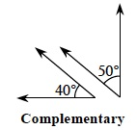
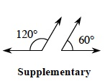
Two angles do not have to share a vertex to be complementary or supplementary. The first pair of angles below are supplementary; the second pair of angles are complementary.

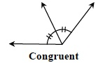
When two angles have equal measure, they are called congruent. Their equality can be shown with matching markings, as shown in the diagram at right.

- 2-8. Find the area of each rectangle below:
a. b. c.
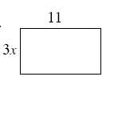
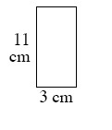
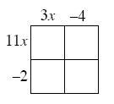

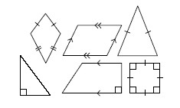
- 2-9. Mei puts the shapes below into a bucket and asks Brian to pick one out.
a. What is the probability that he pulls out a quadrilateral with parallel sides?

b. What is the probability that he pulls out a shape with rotation symmetry?
- 2-11. Jerry has an idea. Since he knows that an isosceles trapezoid has reflection symmetry, he reasons, “That means that it must have two pairs of congruent angles.” He marks the congruent parts on his diagram below.
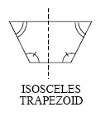
Copy the shapes below onto your paper. Similarly mark which angles must be equal due to reflection symmetry.
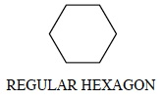
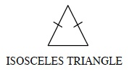
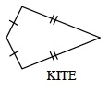

- 2-18. Examine the diagrams below. What is the geometric relationship between the labeled angles? What is the relationship of their measures? Then, use the relationship to write an equation and solve for x.
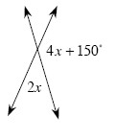
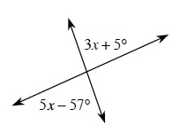

- 2-21. Find the equation for the line that passes through (−1, −2) and (4, 3). Is the point (3, 1) on this line? Be sure to justify your answer.

