• 2-90. Find the area of each figure below. Show all work. Remember to include units in your answer.
- a square:
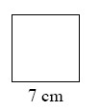
- 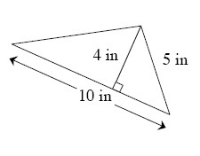
- 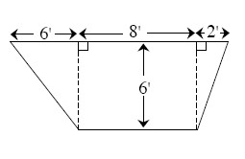
• 2-92. Graph the following equations on the same set of axes. Label each line or curve with its equation. Where do the two curves intersect?
y = −x − 3
y = x² + 2x − 3
• 2-93. On graph paper, plot quadrilateral ABCD if A (2, 7), B (4, 8), C (4, 2), and D (2, 3).
- What is the best name for this shape? Justify your conclusion.
- Quadrilateral A′B′C′D′ is formed by rotating ABCD 90° clockwise about the origin. Name the coordinates of the vertices.
- Find the area of ABCD. Show all work.
• 2-94. What is the probability of drawing each of the following cards from a standard playing deck? Refer to problem 2-74 if you need information about a deck of cards.
- P(face card)
- P(card printed with an even number)
- P(red ace)
- P(purple card)

