3-18. The ratios Casey wrote from the table in part (a) of problem 3-14 are common ratios between corresponding sides of the two shapes. That is, they are ratios between the matching sides of two shapes.
- Look at the two similar shapes below. Which sides correspond? Write common ratios with the names of sides and lengths, just like Bernhard did.
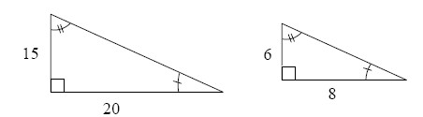
- Find the hypotenuse of each triangle above. Is the ratio of the hypotenuses equal the ratios you found in part (a)?
- 3-27. Rakisha is puzzled. She is working with the parallelogram below and wants to make it smaller instead of bigger.
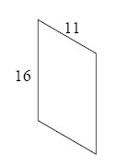
  - What should she do if she wants the sides of her new shape to be half as long as the original sides? What zoom factor should she use? Find the dimensions of her new shape.
  - While drawing some other shapes, Rakisha ended up with a shape congruent to the original parallelogram. What is the common ratio between pairs of corresponding sides?

- 3-28. Enlarge the shape below on graph paper using a zoom factor of 2. Then find the perimeter and area of both shapes. What do you notice when you compare the perimeters? The areas?
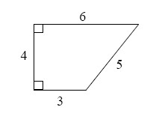
3-31. Examine the diagram below. Name the geometric relationships of the angles below.
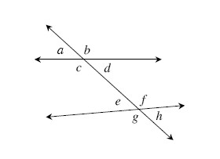
- d and e
- e and h
- a and e
- c and d

