- 3-38. Solve for the missing lengths in the sets of similar figures below.
  - ΔABC ∼ ΔOPQ
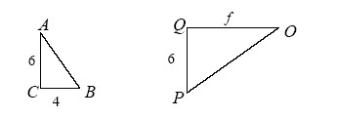
  - EFGHI ∼ STUVW
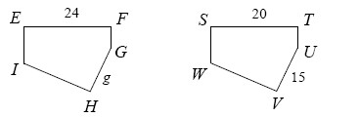
  - JKLM ∼ WXYZ
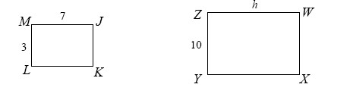

- 3-39. In recent lessons, you have learned that similar triangles have equal corresponding angles. Is it possible to have equal corresponding angles when the triangles do not appear to match? What if you are not given all three angle measures? Consider the two cases below.
  - Find the measure of the third angle in the first pair of triangles below. Compare the two triangles. What do you notice?
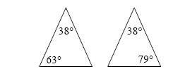
  - Examine the second pair of triangles below. Without calculating, do you know that the unmarked angles must be equal? Why or why not?
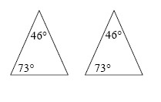
- 3-41. Frank and Alice are penguins. At birth, Frank’s beak was 1.95 inches long, while Alice’s was 1.50 inches long. If Frank’s beak grows by 0.25 inches per year and Alice’s grows by 0.40 inches per year, how old will they be when their beaks are the same length?

- 3-42. Plot ABCDE formed with the points A(−3, −2), B(5, −2), C(5, 3), D(1, 6), and E(−3, 3) onto graph paper.
  - Use the method from problem 3-2 to enlarge it from the origin by a factor of 2. Label this new shape A′B′C′D′E′.
  - Find the area and the perimeter of both figures.

