- 3-49. Decide if each pair of triangles below is similar. If the triangles are similar, justify your conclusion by stating the similarity conjecture you used. If the triangles are not similar, explain how you know.

  - 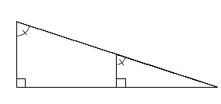
  - 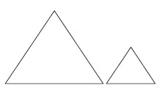
Equilateral Triangles
  - 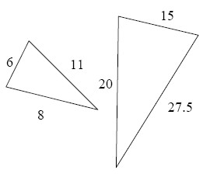
  - 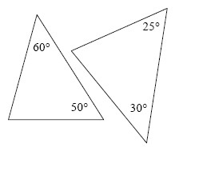

- 3-50. Consider the following arrow diagram:
Lines are parallel → alternate interior angles are equal.
  - Write this arrow diagram as a conditional (“If…, then…”) statement.
  - Write a similar conditional statement about corresponding angles, then write it as an arrow diagram.
- 3-51. Find the area and perimeter of the shape below. Show all work.
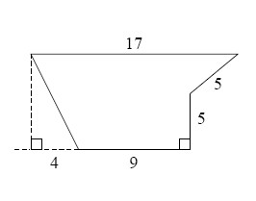
- 3-52. Assume that each pair of figures below is similar. Write a similarity statement to illustrate which parts of each shape correspond. Remember: letter order is important!

  - ABCD ∼ ?
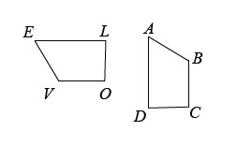
  - RIGHT ∼ ?
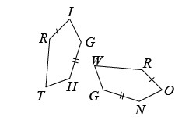
  - Δ____ ∼ Δ____
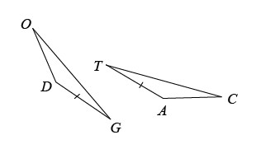

3-62. Determine whether or not the reasoning in the flowchart at right is correct. If it is wrong, redo the flowchart to make it correct. Hints⇔Help
