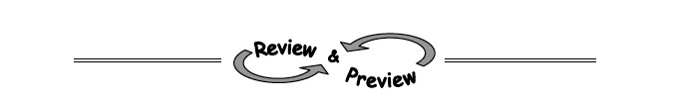
4-25. Write expressions to represent the quantities described below.
  - Geraldine is 4 years younger than Tom. If Tom is t years old, how old is Geraldine? Also, if Steven is twice as old as Geraldine, how old is he?

  - 150 people went to see “Ode to Algebra” performed in the school auditorium. If the number of children that attended the performance was c, how many adults attended?

  - The cost of a new CD is $14.95, and the cost of a video game is $39.99. How much would c CDs and v video games cost?

4-26. Solve the systems of equations below using the Equal Values Method . (Hint: Put the second equation into “y=” form.
y = 7 − 2x
2x + y = 10

4-28. A tile pattern has 10 tiles in Figure 2 and increases by 2 tiles for each figure. Find a rule for this pattern and then determine how many tiles are in Figure 100.

4-30. If f(x) = 3x − 9 and g(x) = −x², find:
  - f(−2)

  - g(−2)

  - x if f(x) = 0

  - g(m)

