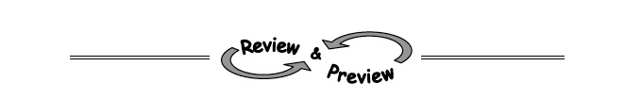
4-37. Solve each equation for the variable. Check your solutions, if possible.
  - 8a + a − 3 = 6a − 2a − 3

  - + 1 = 6

  - 4t − 2+ t² = 6 + t²

4-38. The football team scored an incredible 55 points at last night's game. Interestingly, the number of field goals was 1 more than twice the number of touchdowns. The football team earned 7 points for each touchdown and 3 points for each field goal.
Multiple Choice: Which system of equations below best represents this situation? Explain your reasoning. Assume that t represents the number of touchdowns and f represents the number of field goals.
    - t = 2f + 1
7t + 3f = 55
    - f = 2t + 1
7t + 3f = 55
    - t = 2f + 1
3t + 7f = 55
    - f = 2t + 1
3t + 7f = 55
Then, solve the system you selected in part (a) and determine how many touchdowns and field goals the Fabulous Footballers earned last night.
4-40. Kevin and his little sister, Katy, are trying to solve the system of equations shown below. Kevin thinks the new equation should be 3(6x − 1) + 2y = 43, while Katy thinks it should be 3x + 2(6x − 1) = 43. Who is correct and why?
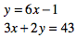

4-41. Simplify each expression.
  - 5⁰ · 2⁻ ³

  - 